**UNIVERSITY OF COLORADO DENVER**

**Interactive Dashboarding in Tableau**

ASSIGNMENT – 12

BANA - 6800

Avi Manawat (student id: 109638446)

**Abstract:**

As the' American Association of Suicidology ' tagline states, I strongly believe that suicide prevention is the business of everyone. Keeping in mind that anything can be resolved with the help of adequate support and lifestyle, the act of ending one's own life specifying the reasons for being depression, alcoholism, social reasons or any other mental illness in that matter is not a good idea. Through this project, I look forward to identifying the trends in suicidal rates by region, gender, age and ethnicity, and to relate these trends to the possible reasons that lead to the drastic decision that could enable us to curb the thinking at the very start.

In this assignment, various visualizations are created in Tableau in order to produce meaningful insights from the data and to understand different dimensions of the data.

**Suicidal rates classified by country**

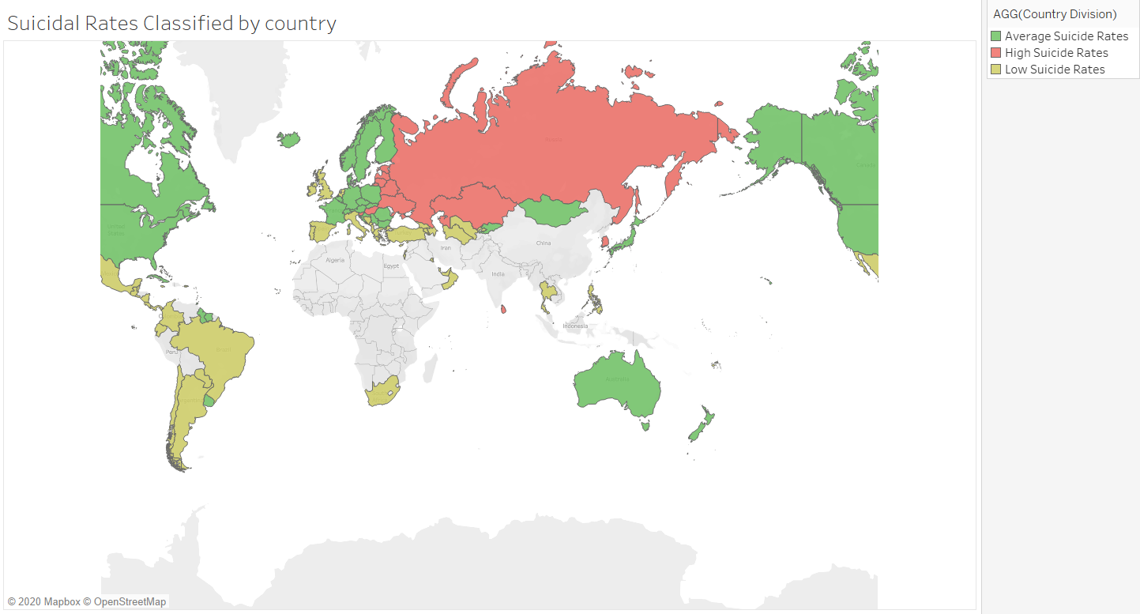

* This is a map that depicts average suicidal rate per 100k population classified by country. High suicidal rates are identified as more than 24 suicide cases per 100k population in that country and is observed in the north-west Asian countries. Medium and Low suicidal rates are depicted by green and yellow colors respectively. The classification was done as shown below:

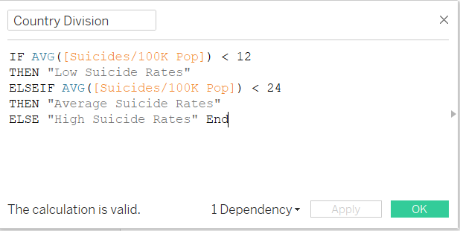

**Suicide Number and population by year**

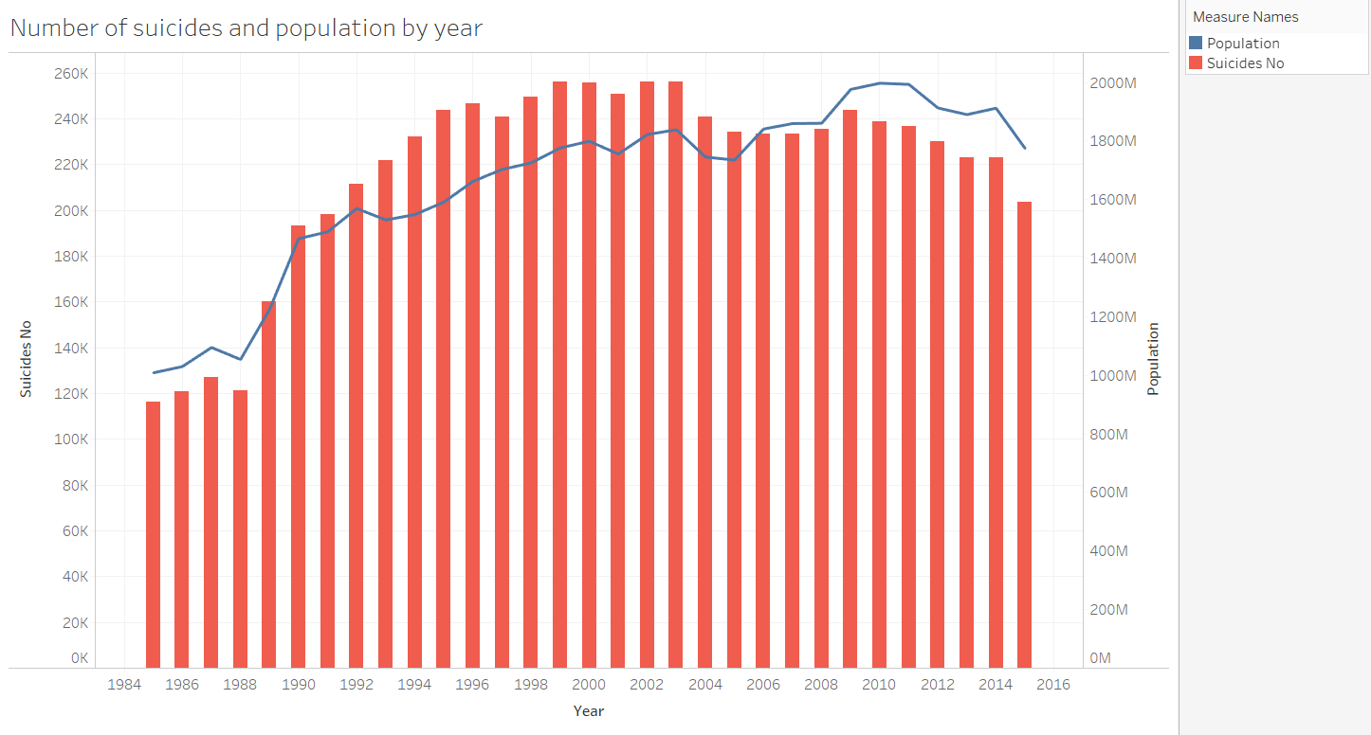

* This is a dual combination chart that shows the total number of suicides by year and the line represents the population over that period. The aim is to determine if population influences rising number of suicidal cases. As observed here, there is a significant increase in the number of suicide cases with the increase in population during the span of 30 years from 1985 to 2015.
* A general trend of more suicide cases in the country are registered if the population of the country itself is more. This might be reason for greater number of cases in countries like United States and Russia.

**Average of suicides per 100k population by gender**

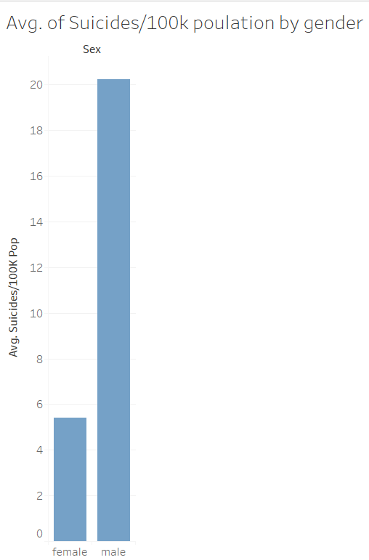

* The above bars represent suicides per 100k population by gender. It is seen that around 20 out of every 100k males commit suicide as compared to only 5 in case of females. We can conclude that male have a higher tendency of committing suicide than female in general.

**Map of number of suicides by country**

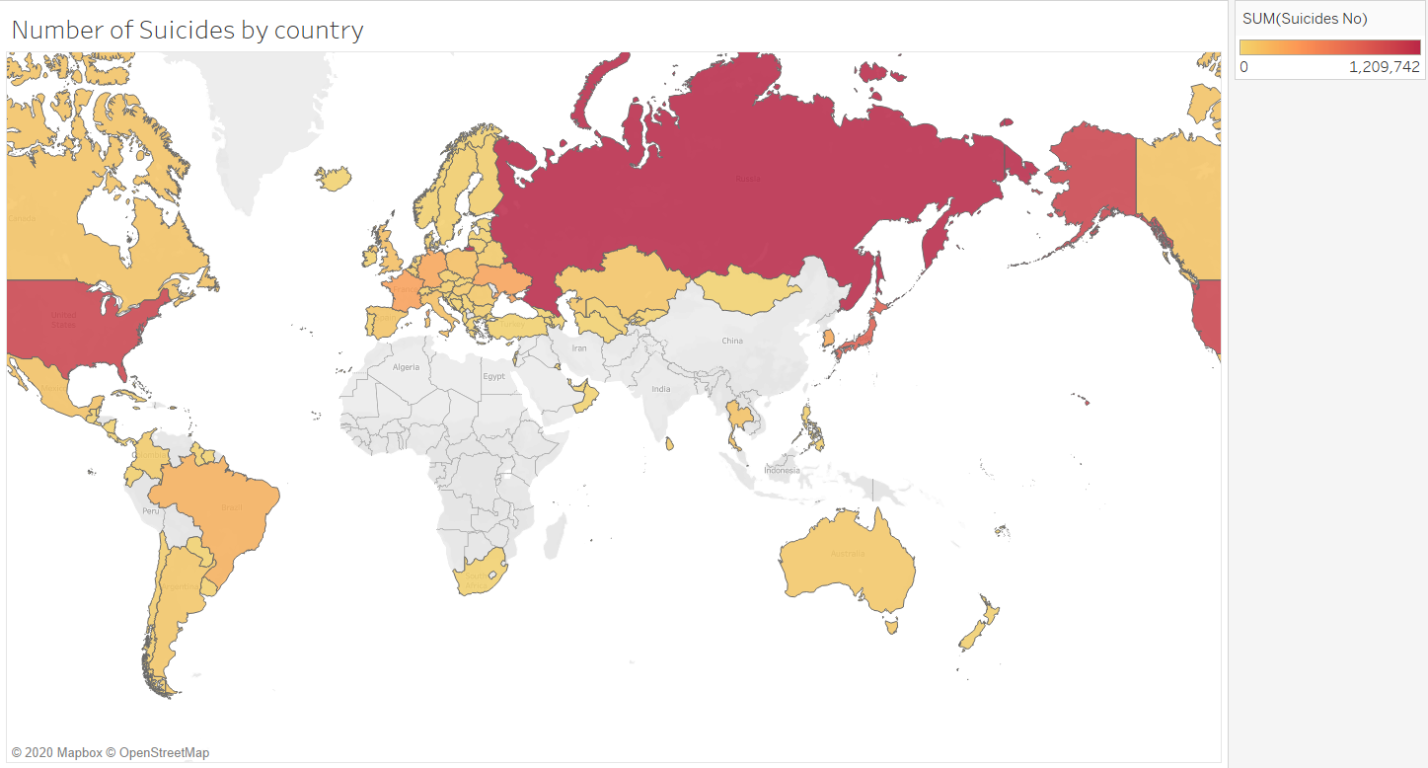

* This map shows the number of suicide cases registered by country. Here, the intensity of the color represents the number of cases in the country i.e., darker color (red) means greater number of suicidal cases in that country. It can be clearly seen here that Russia, United States and Japan are the three countries with maximum number of cases.

**GDP per capita and number of suicides by country**

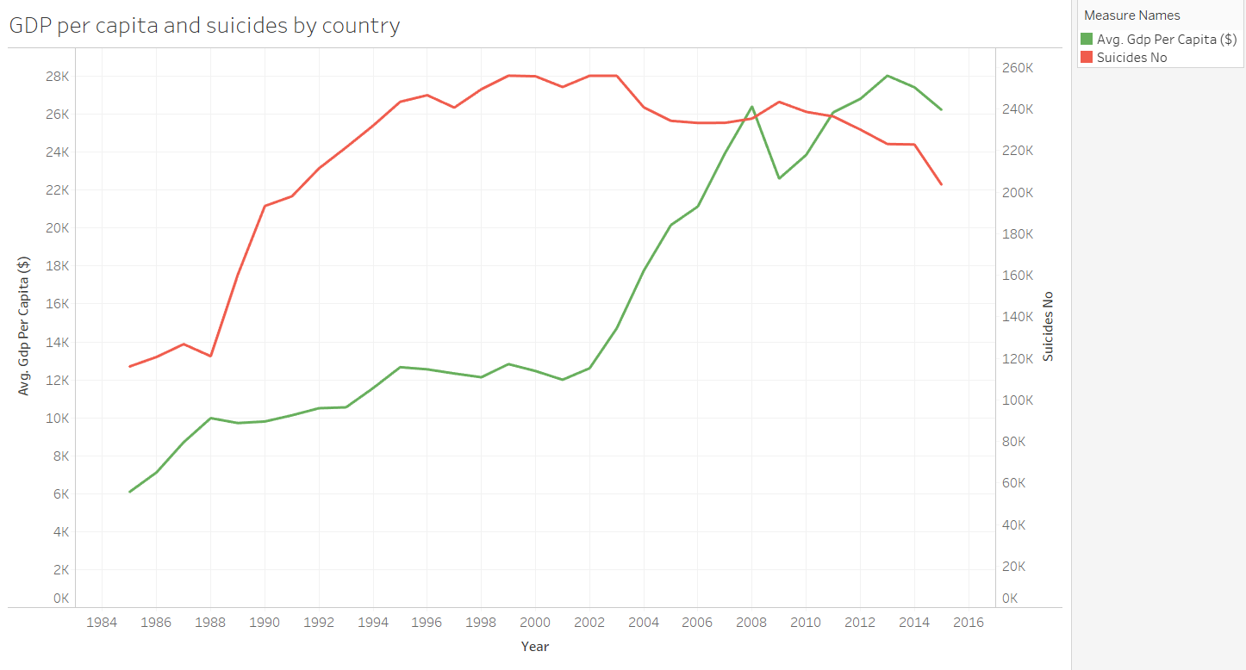

* The above is a Dual Lines chart. The green line shows the average GDP per capita by year while the red line represents the total number of suicide cases in that year. Observing the graph, we can say that there might me some positive relation of suicides and Gdp per capita that means that increasing number of suicide cases has a negative effect on GDP but no solid conclusion can be made.

**Populations and number of suicides by country by gender**

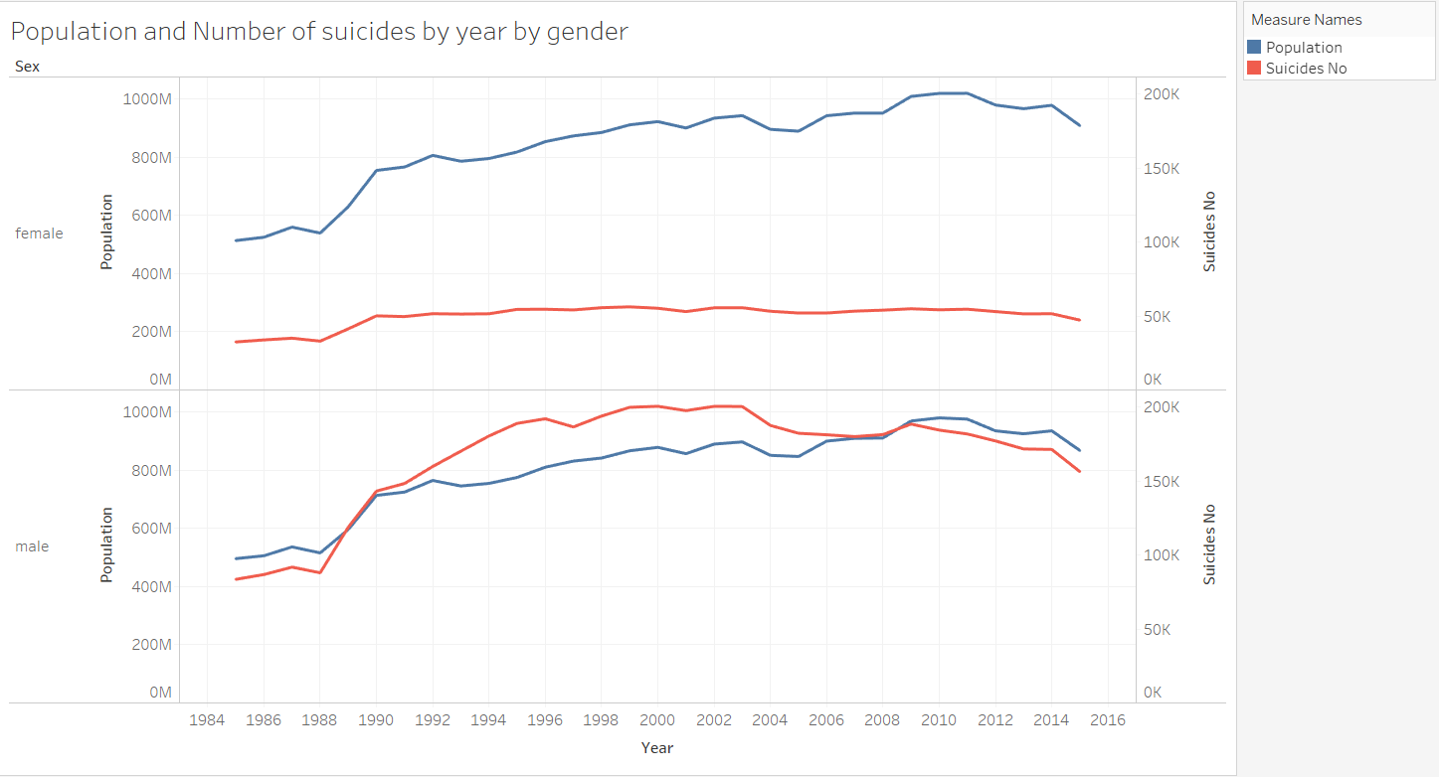

* This is a Line chart (discrete) with Dual Y axis representing population on the 1st axis (blue line) and number of suicide cases on the 2nd axis (red line) classified by gender. As seen here, population plays a major factor contributing to the number of suicidal cases.
* For males, increase in number of suicide cases seems to go hand in hand with population. With increase in population there is increase in the number of male suicidal rates while no such pattern is observed in case of females. The suicidal numbers for females look almost constant over time.

**Population vs Number of suicides by country**

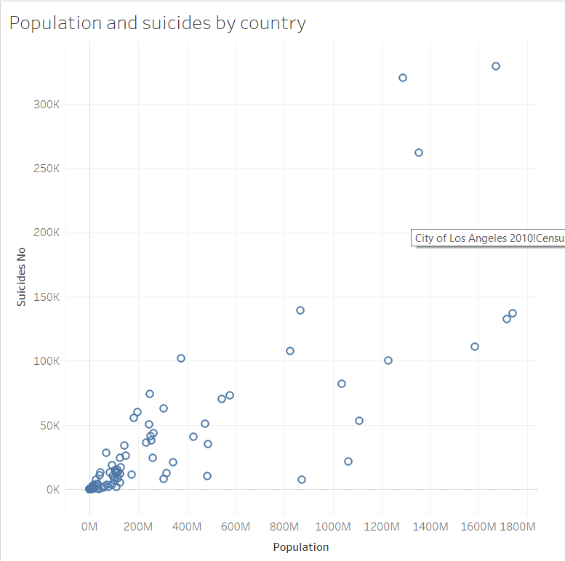

* This is a scatter chart between number of suicidal cases and population plotted to further justify the fact of relationship between population and number of suicides. This plot shows presence of positive correlation between the two variables that means that with increased population, there are more chances of having greater number of suicide cases.

**Average of suicides per 100k population by age**

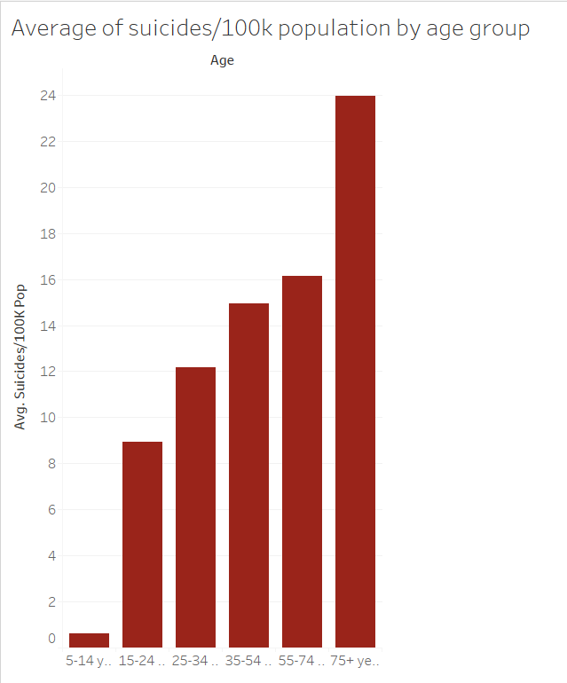

* This is a bar chart of average number of suicide cases per 100k population classified by age. It is very clear from this graph that the average number of suicide cases increase with increase in the age. People above the age of 75 years of age are most prone to commit suicide as compared to the other age groups.
* We might say that as a person grows older, the more he/she comes across the harsh realities of life and looses the will to live. Like a wise man said, “Every problem has a solution”, thus with proper guidance, we can see a significant decrease in these numbers and save lives of many innocent people.

**Treemap of average suicides per 100k population by country**

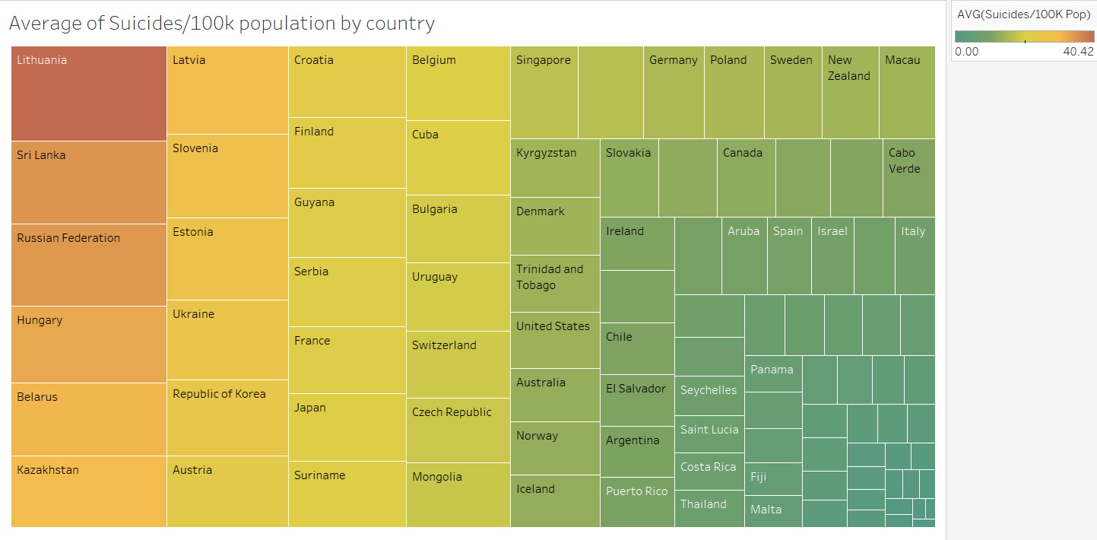

* This is a tree map of average number of suicides per 100k population by country. Lithuania tops the list with an average of around 40 suicide cases per 100 k population while countries in the bottom right corner of the tree map like Turkey, Oman and Jamaica has the lowest average number of suicide cases per 100k population.